Compile-time Polymorphism (Method Overloading)

📌 Definition:
# Source: AI Source: Provided by: [Data Path: Persons Table -> ID Column: 1, Name_En Column: Motasem Essam] -> From: [ChatGPT] on [12/9/2025]
Compile-time polymorphism (also called method overloading) is when multiple methods have the same name but different parameters, and the correct method is chosen at compile time.

🧠 Simple idea:
# Source: AI Source: Provided by: [Data Path: Persons Table -> ID Column: 1, Name_En Column: Motasem Essam] -> From: [ChatGPT] on [12/9/2025]
Compile-time polymorphism = “Same name, different inputs” 🔁

🔍 Key characteristics:
# Source: AI Source: Provided by: [Data Path: Persons Table -> ID Column: 1, Name_En Column: Motasem Essam] -> From: [ChatGPT] on [12/9/2025]
- 🔤 Same method name
- 📊 Different parameter list (number, type, or order)
- ⚙️ Decision made at compile time
- 🧩 Improves readability and usability

📌 Example (Java):
# Source: AI Source: Provided by: [Data Path: Persons Table -> ID Column: 1, Name_En Column: Motasem Essam] -> From: [ChatGPT] on [12/9/2025]
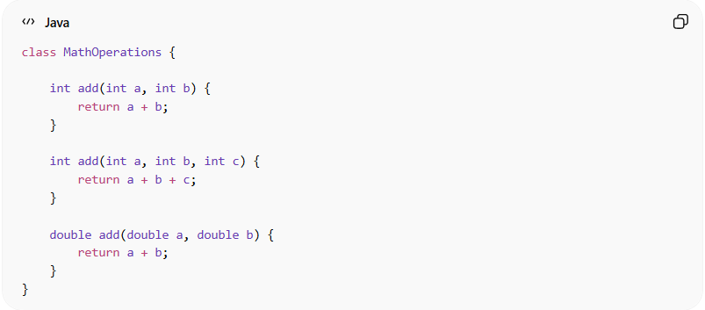
class MathOperations {

int add(int a, int b) {
return a + b;
}

int add(int a, int b, int c) {
return a + b + c;
}

double add(double a, double b) {
return a + b;
}
}

📌 Usage:
# Source: AI Source: Provided by: [Data Path: Persons Table -> ID Column: 1, Name_En Column: Motasem Essam] -> From: [ChatGPT] on [12/9/2025]
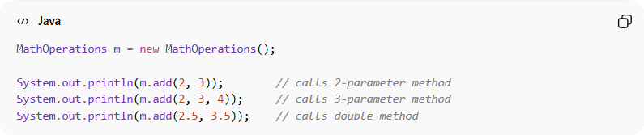
MathOperations m = new MathOperations();

System.out.println(m.add(2, 3)); // calls 2-parameter method
System.out.println(m.add(2, 3, 4)); // calls 3-parameter method
System.out.println(m.add(2.5, 3.5)); // calls double method
👉 The correct method is selected based on the arguments.

⚙️ What can differ in overloading:
# Source: AI Source: Provided by: [Data Path: Persons Table -> ID Column: 1, Name_En Column: Motasem Essam] -> From: [ChatGPT] on [12/9/2025]
- ✔️ Number of parameters
- ✔️ Type of parameters
- ✔️ Order of parameters

❗ What cannot differ:
# Source: AI Source: Provided by: [Data Path: Persons Table -> ID Column: 1, Name_En Column: Motasem Essam] -> From: [ChatGPT] on [12/9/2025]
- ❌ Return type alone (must differ in parameters)

🎯 Why it is useful:
# Source: AI Source: Provided by: [Data Path: Persons Table -> ID Column: 1, Name_En Column: Motasem Essam] -> From: [ChatGPT] on [12/9/2025]
- 🧩 Improves code clarity
- 🔄 Makes code more flexible
- 📦 Allows same operation for different data types
- 🧠 Easier to understand and use

🎯 Summary:
# Source: AI Source: Provided by: [Data Path: Persons Table -> ID Column: 1, Name_En Column: Motasem Essam] -> From: [ChatGPT] on [12/9/2025]
Compile-time polymorphism (method overloading) allows multiple methods with the same name but different parameters, and the correct method is chosen during compilation.

